/ ADMISSIONS POLICY /

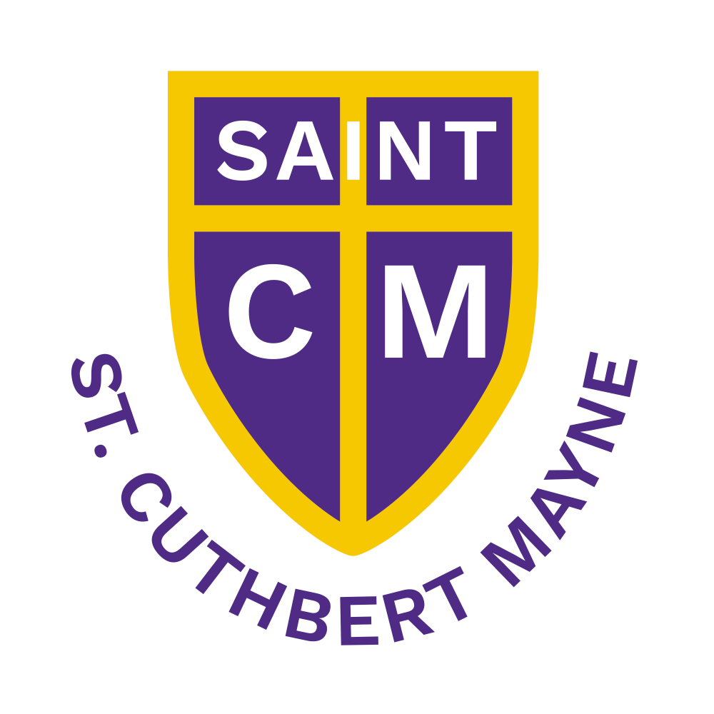

St Cuthbert Mayne

Catholic Primary School

A Catholic School in the Diocese of Arundel and Brighton

St. Nicolas Avenue, Cranleigh, Surrey GU6 7AQ
Telephone: 01483 274961 Fax: 01483 273 683
Email: info@stcuthbert-mayne.surrey.sch.uk
www.stcuthbert-mayne.surrey.sch.uk

ADMISSIONS POLICY

For admission in 2026-27

Age range for school: 4-11
Expected number on roll in September 2026: 210

The School’s admission arrangements (i.e Policy and Supplementary Information Form)
Next Review: Autumn 2025

Admissions Policy for admission in 2026–27

St Cuthbert Mayne Catholic Primary School was founded by the Catholic Church to provide education for children of Catholic families. The school is conducted by its governing body as part of the Catholic Church in accordance with the trust deed of the Diocese of Arundel & Brighton and its articles of association, and seeks at all times to be a witness to Jesus Christ.

As a Catholic school, the governors aim to provide a Catholic education for all pupils. At a Catholic school, Catholic doctrine and practice permeate every aspect of the school’s activity. The governors ask all parents applying for a place to respect this ethos and its importance to the school community.

Although Catholic children have priority of admission, this does not affect the right of an applicant who is not Catholic to apply for a place for their child at the school. The school welcomes applications from those of other denominations and faiths, or of none. The school was set up primarily to serve the Catholic community in the parish of Cranleigh and Bramley.

An outline map of the parish can be seen below:

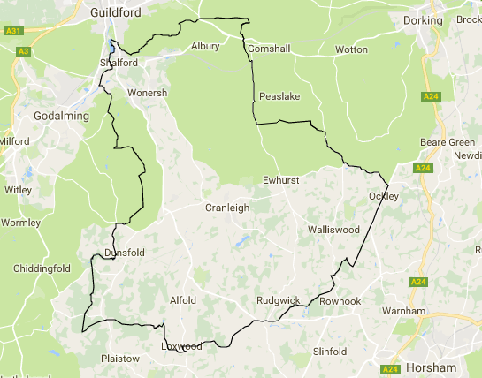

A zoomable map of the parish can be viewed at: www.abdiocese.org.uk/education/find-a-school

The governing body is the admissions authority and has responsibility for admissions to this school, including setting the priority of admissions when the school is oversubscribed. The Local Authority undertakes the co-ordination of admission arrangements during the normal admission round. The governing body has set its admission number at 30 pupils to be admitted to the Reception Year in the school year which begins in September 2026.

Visiting the School
Parents/carers are encouraged to visit our school in order to find out more about how we work and the education we offer. Parents/carers are welcome to arrange a visit by contacting the school admissions officer on 01483 274961. However, such visits do not form part of the process of deciding which children are to be offered a place at the school.

Pupils with an Education Health and Care Plan (see note a.)
The admission of pupils with an Education, Health and Care Plan is dealt with by a completely separate procedure. Children with an Education, Health and Care Plan that names the school must be admitted. Where this takes place before the allocation of places under these arrangements, this will reduce the number of places available to other children.

Oversubscription Criteria:

At any time where there are more applications for places than the number of places available, places will be offered according to the following order of priority:

- Catholic looked after children or previously looked after children (see notes b. & c.).

- Catholic children with a brother or sister (see note f.) at the school at the time of admission, resident in the Cranleigh and Bramley parish (see note h.).
The application must be supported with a certificate of Catholic baptism or reception into the Catholic Church (see note c.).

- Catholic children with a brother or sister (see note f.) at the school at the time of admission, who are not resident in the Cranleigh and Bramley parish (see note h.).
The application must be supported with a certificate of Catholic baptism or reception into the Catholic Church (see note c.).

- Catholic children without a brother or sister (see note f.) at the school at the time of admission, resident in the Cranleigh and Bramley parish (see note h.).
The application must be supported with a certificate of Catholic baptism or reception into the Catholic Church (see note c.).

- Catholic children without a brother or sister (see note f.) at the school at the time of admission, who are not resident in the Cranleigh and Bramley parish (see note h.).
The application must be supported with a certificate of Catholic baptism or reception into the Catholic Church (see note c.).

- Other looked after children or previously looked after children (see note b.).

- Catechumens, Candidates for Reception into the Church and children who are members of an Orthodox Church (see note d. & e.).
If application is being made for a place at the school where the parent/carer is a Catechumen or Candidate for reception into the Church, evidence of their being a member of the Catechumenate of a Catholic Church or a Candidate for reception will be required. Proof of acceptance into the catechumenate, and evidence for a candidate, should be by letter from the appropriate priest.

Applications for children from an Orthodox Church must be supported with either a certificate of baptism or a letter confirming membership of the applicable Orthodox Church, signed by the appropriate priest.

- Other children with a brother or sister (see note f.) at the school at the time of admission.

- Children of staff in either or both of the following circumstances:
- A permanent member of staff that has been employed at the school for at least two years at the time of application (see note m.)
- A member of staff recruited to fill a vacant post for which there is a demonstrable skill shortage (see note m.)

- Children of other Christian denominations (see note k.) whose membership is evidenced by a minister of religion.
The application must be supported by either a certificate of baptism or a letter confirming membership of the Christian denomination, signed by the minister of religion.

- Children of other faiths (see note l.) whose membership is evidenced by a religious leader.
The application must be supported by a letter confirming membership of that faith, signed by the faith leader.

- Any other children.

Final Tiebreaker:
Priority will be given to children living closest to the school determined by the shortest distance (see note j.).

_____________________________________________________________________________________
Application Procedure

To apply for a place at this school in the normal admissions round, you should complete and return the following two forms:

- The COMMON APPLICATION FORM (CAF)
All applications for places must be made on the Common Application Form which is available either from the Local Authority (where the parent lives) or through that Local Authority’s website. For a valid application, the completed CAF must be returned either online or in the paper form by 15 January 2026.

- The school’s SUPPLEMENTARY INFORMATION FORM (SIF)
This is available from the school and the school website and allows the governors to put all applicants in order of priority for admission in line with the published admission policy.

If you are expressing a preference for a place for your child at this school and wish to apply in connection with one of the faith criteria, you need to complete the SIF.

If you do not complete the SIF and return it to the school with all supporting documents by the closing date, your child may not be placed in the appropriate faith criterion. This is likely to affect your child’s chance of being offered a place.

For a Reception Year admission in the normal admissions round for the year 2026-27, the completed SIF, together will all supporting documents, should be returned to the school by 15 January 2026. Note: If the school receives an incomplete SIF, this might affect your child’s chance of being offered a place.

You are advised to keep copies of the forms for your records (whether completed online/on paper).

Late Applications
All paperwork should be returned before the published closing dates referenced above. You are encouraged to ensure that your application is received on time.

Any late applications will be dealt with in accordance with the Local Authority’s Co-ordinated Admissions Scheme.

Deferred entry
Schools are required to provide for the admission of all children in the September following their fourth birthday. The parent/carer has the following options where the governing body has offered the child a place at the school. The parent/carer can decide either:
- That the child starts school full-time in the September following their fourth birthday with their natural academic cohort; or
- To defer the date their child is admitted to the school until later in the school year but not beyond the point at which they reach compulsory school age and not beyond the beginning of the final term of the school year; or
- That the child starts school on a part-time basis until later in the school year but not beyond the point at which they reach compulsory school age.

Admission of Children Outside their Normal Age Group
Please note that it is the view of the Government, the Diocese, the LA and the Governing Body of this school that a child is educated alongside his/her age equivalent peers, in almost all cases.

Should a parent/carer request to have a decelerated entry to school, that is to start later than other children in their chronological age group, they should initially apply for a school place in accordance with the deadlines that apply for their child’s chronological age.

If the request is accepted, the application for the normal year group may be withdrawn before a place is offered. The parent/carer will be required to apply in the usual way the following year, along with the cohort of applicants for that year group. It should be noted that the application will not receive priority over or above any other applicant for this year group and the application will be considered alongside all other applicants to the school.

If a parent/carer requests to have an accelerated entry to school ie to start earlier than other children in the chronological age group, they should initially apply for a school place at the same time that other families are applying for that cohort. If the governing body agrees for the child to have an accelerated entry, the application will be processed. If it is not agreed for the child to have an accelerated entry they will be invited to apply again in the following year for the correct cohort.

In relation to the request, decisions are made on the basis of the circumstances of each case and in the best interests of the child. The governing body will expect the parent/carer to supply them with appropriate information and evidence. What the governing body will take into account will include:

- Views of parent/carer
- Information relating to the child’s academic, social and emotional development, where relevant
- Medical history and the views of a medical professional
- Any previous history of being educated outside of their normal age group
- If the child may naturally have fallen into a lower age group if it were not for being born prematurely
- View of the headteacher of the school.

Please note that parents/carers do not have the right to insist that their child is admitted to a particular age group. It is the governing body who, having considered the circumstances of each individual case, will make a decision. The governing body will set out clearly for the parents/carers concerned the reasons for their decision in each case.

If the parent/carer is unhappy with a decision about which year group their child will be admitted to, the following applies. Parents/carers who are refused a place at a school for which they have applied have the right of appeal to an independent admission appeal panel. However, there is not a right of appeal if the child has been offered a place and it is not in the year group the parent/carer would like. In such cases, the parent/carer could make a complaint through the school’s complaint procedure.

Waiting Lists
In addition to their right of appeal, if a place is not offered because of over-subscription, the child’s name will be placed on a waiting list. The list will be in the descending hierarchical order of the categories in the admissions criteria. The list will continue for the year group until the end of the academic year. If a place is offered and declined the child’s name will be removed from the waiting list.

Parents/carers who wish their child’s name to remain on a waiting list beyond this time are requested to contact the school in writing by the end of July 2027. If a place is offered and declined the child’s name will be removed from the waiting list.

It should be noted that no matter how long a child’s name has been on the waiting list, his or her position on the list may change if the school adds a child’s name to the list, which has a higher priority according to the oversubscription criteria. The school is also under a duty to admit children who are presented for admission under the Local Authority’s ‘Fair Access Protocol’. These children must take precedence over any children already on the waiting list.

In Year Admissions
The oversubscription criteria in this admission policy will also apply to applications made outside the normal age of entry to primary education (Reception Year) i.e. in succeeding years or during the academic year.

By latest 31 August 2026, the school’s website will set out how in-year applications will be dealt with from 1 September 2026 to 31 August 2027. This will include how parents / carers can apply for a school place when parents / carers will be notified of the outcome of their application and details about the right to appeal.

Offer of a Place
The Local Authority will inform you of your allocated place on the national offer date of 16 April 2026. Note: National Offer Date is usually 16 April. However, if this day falls on a weekend/bank holiday, it is the first working day after.

Appeals
If your child is not offered a place at St Cuthbert Mayne Catholic Primary School, Cranleigh, you have the right to appeal against that decision to an Independent Appeal Panel (set up in accordance with sections 88 and 94 of the School Standards and Framework Act 1998). Appeals must be made in writing and must set out the reasons on which the appeal is made. Appeals should be made to the Admissions Appeal Clerk at the school address. Appeals should be lodged no later than 20 school days after the National Offer Day for primary schools (16 April 2026). Completed paperwork must be received by the school no later than 17 May 2026, and will be heard within 40 school days. The appeals system is operated independently from the school. Parents/carers have the right to make oral representations to the Appeal Panel.

Late application appeals will be heard within 30 school days of the appeal being lodged.

In-year applications will be heard within 30 school days of the appeal being lodged.

Fair Access Protocol (FAP)
The school is committed to taking its fair share of children who are vulnerable and/or hard to place, as set out in locally agreed protocols. Accordingly, outside the normal admission round, the governing body is empowered to give absolute priority to a child where admission is requested under any locally agreed protocol. Alternatively, where a FAP headteacher panel is in place, the governing body may authorise the headteacher (or nominated representative) to partake in placement decisions under the LA agreed FAP. The governing body has this power even where admitting the child would mean exceeding the published admission number.

Giving the school false information
If a parent/carer is found to have supplied false or incorrect information to gain a place at this school, the governing body reserves the right to withdraw any offer of a place even if the child has already started school. An example of false or incorrect information would be the use of an address that is not the child’s normal residence.
_________________________________________________________________________________
Notes (these form part of the admission arrangements):

- An ‘Education, Health and Care Plan’ is a plan made by the Local Authority under section 37 of the Children and Families Act 2014, specifying the special educational provision required for a child.

- A ‘Looked after child’ has the same meaning as in section 22(1) of the Children Act 1989, and means any child who is (i) in the care of a local authority or (ii) being provided with accommodation by them in the exercise of their social services functions (e.g. children with foster parents) at the time of making application to the school. A ‘Previously looked after child’ is a child who was looked after but ceased to be so because he or she was adopted or became subject to a child arrangement order or special guardianship order. Previously looked-after children also includes those children who appear (to the Governing Body) to have been in state care outside of England and cease to be in state care as a result of being adopted. A child will be regarded as having been in state care outside of England if they were accommodated by a public authority, a religious organisation or any other provider of care whose sole or main purpose is to benefit society. The parent / carer will need to provide evidence to demonstrate that the child was in state care outside of England and left that care as a result of being adopted.

- ‘Catholic’ means a member of a Church in full communion with the See of Rome. This includes the Latin Rite (Roman Catholics) and the Eastern Catholic Churches (see Appendix 1 of the Diocesan Admissions Guidance for a list of Churches in full communion with the See of Rome). This will normally be evidenced by a certificate of Baptism in a Catholic Church or a certificate of reception into the full communion of the Catholic Church. For the purposes of this policy, it includes a looked after child who is part of a Catholic family where a letter from a priest demonstrates that the child would have been baptised or received into the Church if it were not for their status as a looked after child (e.g. a looked after child in the process of adoption by a Catholic family).

For a child to be treated as Catholic, evidence of baptism or reception into the Church will be required. In terms of an application to this school, a child will not be treated as Catholic if the date for baptism or the ceremony of acceptance into the Catholic Church is after the closing date for applications. Those who have difficulty obtaining written evidence of baptism should contact their parish priest who, after consulting with the Diocese, will decide how the question of baptism is to be resolved and how written evidence is to be produced in accordance with the laws of the Church.

- ‘Catechumen’ means a person who wishes to be baptised and has been accepted into the Order of Catechumens through the appropriate liturgical rite. ‘Candidate’ means a baptised member of a non-Catholic denomination who is preparing for admission into full communion with the Catholic Church. Proof of acceptance into the catechumenate, and evidence for a candidate should be by a letter from the appropriate priest.

- ‘Orthodox Churches’ are those eastern Churches not in full communion with the Catholic Church, who have retained the Catholic tradition regarding the sacraments. In this group are included (for the purpose of admissions) members of other Churches which the Apostolic See judges to be in the same position as the aforesaid eastern Churches as far as the sacraments are concerned. Membership is normally evidenced by a certificate of baptism or reception from the authorities of that Church.

- ‘Brother or sister’: For admission to this school, a brother or sister is defined as a natural brother or sister (i.e. another child of the same parents, whether living at the same address or not), or a half-brother/ half-sister or a step-brother/ step-sister or an adoptive or foster brother/ sister, living at the same address. A child will be given a ‘brother or sister’ priority if they have a brother or sister at the school at the time of the child’s admission.

- Parents/Carers: A parent/carer means all natural parents, any person who is not a parent but has parental responsibility for a child, and any person who has care of a child.

- Parish Boundaries: For the purposes of the admission arrangements for the year 2025-26, the parish boundaries are as shown on the map in this policy. A zoomable map is available at:
www.abdiocese.org.uk/education/find-a-school

- Multiple Births: In the event of applications from parents/carers relating to children of multiple births (e.g. twins or triplets etc.), the governing body will admit twins and all siblings from multiple births where one of the children is the last child ranked within the school’s published admission number.

- Distance: Distance will be measured in a straight line from the child’s home address to the nearest gate for pupils to use at the school using the Local Authority’s computerised measuring system.

A child’s home address is considered to be a residential property that is the child’s only/main residence and not an address that is sometimes used due to certain domestic/special arrangements. The address must be the pupil’s home address that applies at the closing date for applications and which is either owned by the child’s parent, parents, or guardian OR leased or rented by the child’s parent, parents or guardian under a lease or written rental agreement OR, if it is a relative’s address or temporary address, it is the ‘main place of residence’. If parents live separately but share responsibility for the child, and the child lives at two different addresses during the week, the ‘home address’ will be regarded as the one at which the child sleeps for the majority of weekday nights. If two addresses are provided, the Local Authority will decide which address should be used as the main residence for the purpose of processing the application as they only accept one current address. Parents/carers must notify the school about any address changes during the application deadlines to ensure all applications are treated in the same way.

In some cases, applicants who live in the same block of flats may share the same address point. In such cases, applicants will be considered to be living equidistant from the school. In the unlikely event that any two or more children live equidistant from the school, and in all other ways have equal eligibility for a place, the names will be issued a number and drawn randomly to decide which child receives priority. This will be supervised by a person independent of the school.

- ‘Children of other Christian denominations’ means children who belong to other churches and ecclesial communities which, acknowledging God’s revelation in Christ, confess the Lord Jesus Christ as God and Saviour according to the Scriptures, and, in obedience to God’s will and in the power of the Holy Spirit commit themselves: to seek a deepening of their communion with Christ and with one another in the Church, which is his body; and to fulfil their mission to proclaim the Gospel by common witness and service in the world to the glory of the one God, Father, Son and Holy Spirit. An ecclesial community which on principle has no credal statements in its tradition, is included if it manifests faith in Christ as witnessed to in the Scriptures and is committed to working in the spirit of the above.

All members of Churches Together in England and of Churches Together in Wales are deemed to be included in the above definition, as are all other churches and ecclesial communities that are in membership of any local Churches Together Group (by whatever title) on the above basis.

- ‘Children of other faiths’ means children who are members of a religious community that does not fall within the definition of ‘other Christian denominations’ and which falls within the definition of a religion for the purposes of charity law. The Charities Act 2011 defines religion to include:
- A religion which involves belief in more than one God and,
- A religion which does not involve belief in a God.
Case law has identified certain characteristics which describe the meaning of religion for the purposes of charity law, which are characterized by a belief in a supreme being and an expression of belief in that supreme being through worship.

- ‘Children of staff’ are defined as the children of those who are employed directly by the school in any capacity, on a permanent contract for two or more years, whether full or part time. For normal round applications, the date that will be used to assess this will be the closing date for applications (i.e.15 January 2024). For in-year applications, the date that will be used will be the date the application is made. ‘Demonstrable skill shortage’ will be determined by the school’s governing body. It must be evidenced by normal recruitment methods having failed to obtain a sufficiently qualified / experienced candidate for an establishment position over a period of not less than three months. Applicants will need to complete, where applicable, the appropriate sections(s) of the Supplementary Information Form (SIF).

