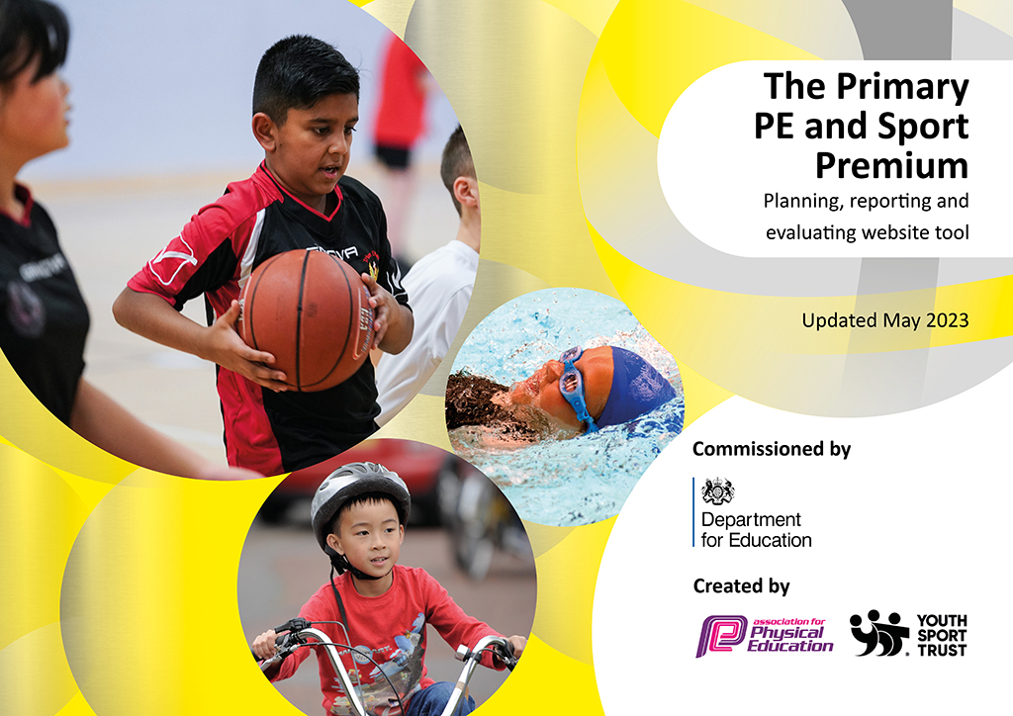
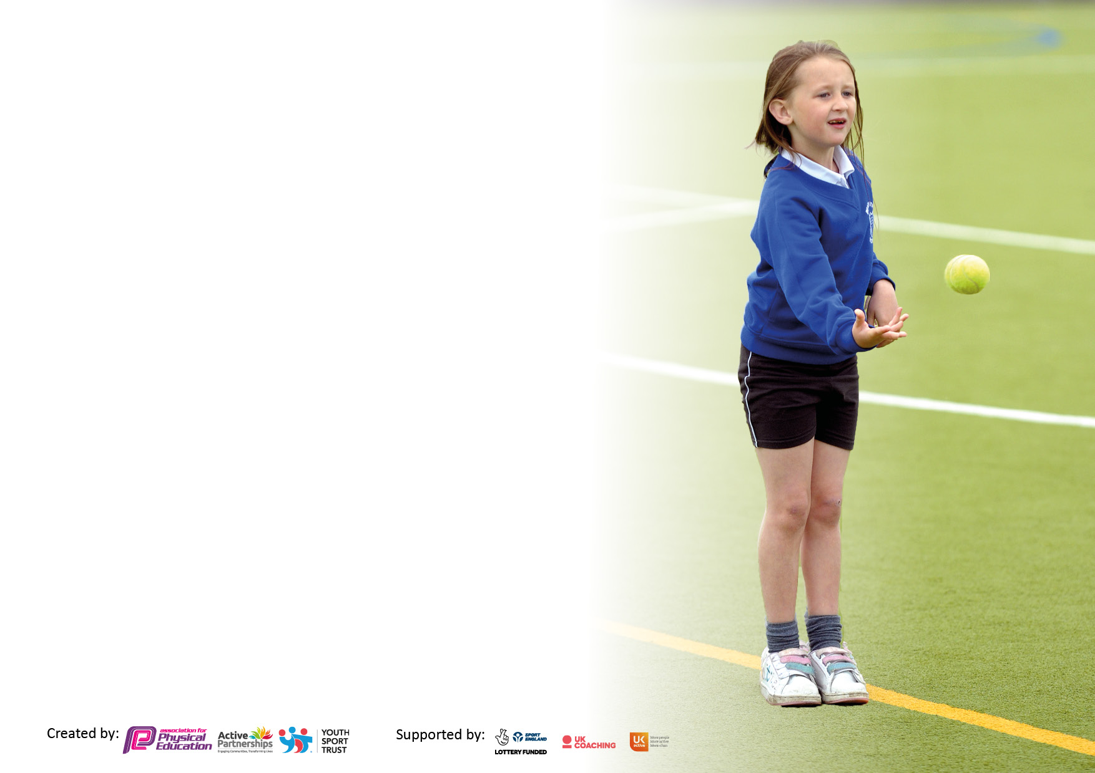

It is important that your grant is used effectively and based on school need. The Education Inspection Framework makes clear there will be a focus on ‘whether leaders and those responsible for governors all understand their respective roles and perform these in a way that enhances the effectiveness of the school’.

Under the Quality of Education Ofsted inspectors consider:
Intent - Curriculum design, coverage and appropriateness
Implementation - Curriculum delivery, Teaching (pedagogy) and Assessment
Impact - Attainment and progress

To assist schools with common transferable language this template has been developed to utilise the same three headings which should make your plans easily transferable between working documents.

Schools must use the funding to make additional and sustainable improvements to the quality of Physical Education, School Sport and Physical Activity (PESSPA) they offer. This means that you should use the Primary PE and sport premium to:

- Develop or add to the PESSPA activities that your school already offer
- Build capacity and capability within the school to ensure that improvements made now will benefit pupils joining the school in future years
- The Primary PE and sport premium should not be used to fund capital spend projects; the school’s budget should fund these.

Please visit gov.uk for the revised DfE guidance including the5keyindicatorsacrosswhichschoolsshoulddemonstrate an improvement. This document will helpyoutoreviewyourprovisionandtoreportyourspend.DfEencouragesschools to use this template as an effective way of meeting the reporting requirements of the Primary PE and Sport Premium.

We recommend you start by reflecting on the impact of current provision and reviewing the previous spend.

Schools are required to publish details of how they spend this funding, including any under-spend from 2021/2022, as well as on the impact it has on pupils’ PE and sport participation and attainment. The funding should be spent by 31st July but the DfE has stated that there will be no clawback of any unspent money so this can be carried forward into 2023/24.

We recommend regularly updating the table and publishing it on your website throughout the year. This evidences your ongoing self-evaluation of how you are using the funding to secure maximum, sustainable impact. Final copy must be posted on your website by the end of the academic year and no later than the 31st July 2023. To see an example of how to complete the table please click HERE.

Details with regard to funding
Please complete the table below.

Total amount carried over from 2021/22 | £0
Total amount allocated for 2021/22 | £17,711
How much (if any) do you intend to carry over from this total fund into 2022/23? | £0
Total amount allocated for 2022/23 | £17,850
Total amount of funding for 2022/23. Ideally should be spent and reported on by 31st July 2023. | £17,850
Swimming Data
Please report on your Swimming Data below.

Meeting national curriculum requirements for swimming and water safety.

N.B. Complete this section to your best ability. For example you might have practised safe self-rescue techniques on dry land which you can then transfer to the pool when school swimming restarts.
Due to exceptional circumstances priority should be given to ensuring that pupils can perform safe self rescue even if they do not fully meet the first two requirements of the NC programme of study
What percentage of your current Year 6 cohort swim competently, confidently and proficiently over a distance of at least 25 metres?  N.B. Even though your pupils may swim in another year please report on their attainment on leaving primary school at the end of the summer term 2023.  Please see note above | 90%
What percentage of your current Year 6 cohort use a range of strokes effectively [for example, front crawl, backstroke and breaststroke]?  Please see note above | 90%
What percentage of your current Year 6 cohort perform safe self-rescue in different water-based situations? | 90%
Schools can choose to use the Primary PE and sport premium to provide additional provision for swimming but this must be for activity over and above the national curriculum requirements. Have you used it in this way? | No

Action Plan and Budget Tracking
Capture your intended annual spend against the 5 key indicators. Clarify the success criteria and evidence of impact that you intend to measure to evaluate for pupils today and for the future.

Academic Year: 2022/23 | Total fund allocated: | Date Updated:
Key indicator 1: The engagement of all pupils in regular physical activity – Chief Medical Officers guidelines recommend that primary school pupils undertake at least 30 minutes of physical activity a day in school |  |  |  | Percentage of total allocation:
 |  |  |  | %
Intent | Implementation |  | Impact
Your school focus should be clear what you want the pupils to know and be able to do and about  what they need to learn and to  consolidate through practice: | Make sure your actions to achieve are linked to your intentions: | Funding allocated: | Evidence of impact: what do pupils now know and what can they now do? What has changed?: | Sustainability and suggested next steps:
Improved activity opportunities at playtime to promote engagement of all children in physical activity. | TA’s trained and continue to run lunchtime sports play activities to promote Positive Play.  Ongoing updates and training through Teaching Assistant meetings (5x20 minutes) with SENDCo or AHT.  Purchased equipment for lunch time activities. School council and all children involved to raise profile. Range of equipment available.  Allocation of areas for competitive sports at playtime eg football, hand ball  SLT visit to another school in the MAT to observe zones at playtime run by Y5/6 children. | £7,910 | Increases pupil participation in activities  Increases interest in sport and a healthy lifestyle  Contributes towards the engagement of all pupils in regular physical activity and raising of heart rate  Provides a broad experience of a range of sports and activities  Positive impact on mental health and well-being, selfesteem  Children demonstrate increased teamwork, cooperation and develop a growth mindset. | Continued PD training for TA’s to deliver Positive Play.  Ensure funding to promote equipment to facilitate a range of activities at playtime.  Y5 &Y6 Sports Crew to be trained through Active Surrey programme to repeat sporting leadership opportunities over the year.  Y5&6 to run Infant Sports Day stations.  Y5&6 to run inter school sporting events for KS1 children to encourage their involvement in competitive sports.
Promote sport in breakfast and afterschool clubs using sports coaches | Provide opportunity to engage in range of activities with specialist coaches | £2,155 | Provides children with the opportunity to experience adventurous activities, build self-esteem, teamwork and mental health. | Continued monitoring of Pupil Premium children and ensuring they are able to experience adventurous activities and continued participation.
Promoting activity and movement throughout school day to improve fitness and model a way of life | All children are active at different times throughout the day including during lessons.  Culture of daily class activity breaks with whole class participation.  Time spent sat at tables minimised – there is a growing expectation in the school culture is to reduce this.  Celebrate and promote activity through Acti-points. | £425 | Over 35000 actipoints given out in 10 months noting activity where heart rate is raised.  Use of skipping ropes and mile a day with classes.  TAs promoting and celebrating activity at playtimes. | New focus to promote activity.  Continued focus on activity within lessons with reduction of long time at desks.  Promotion of daily activity to raise heart rate within EYFS and Y5.
Key indicator 2: The profile of PESSPA being raised across the school as a tool for whole school improvement |  |  |  | Percentage of total allocation:
 |  |  |  | %
Intent | Implementation |  | Impact
Your school focus should be clear what you want the pupils to know and be able to do and about  what they need to learn and to  consolidate through practice: | Make sure your actions to achieve are linked to your intentions: | Funding allocated: | Evidence of impact: what do pupils now know and what can they now do? What has changed? | Sustainability and suggested next steps:
Two hours dedicated to high quality PE teaching per week by trained, experienced coaches for all children. | Ensure coaches have clear planning and skills progression.  Liaison time with PE lead (4 hours per term)  Lessons monitored by PE lead (7 hours per term) and school expectations for behavior and attitude consistent with class teachers.  Full 2 hours used for activity- no changing time.  Additional time allocated in Years 2&3 for swimming, including walking to and from the leisure center. | Separate budget | Quality lessons observed.  Promotion of excellent behavior and effort in PE lessons.  Children enjoy PE and want to take part.  Greater consistency within quality of lessons and behavior expectations within Planet Soccer staff. | Joint monitoring of lessons with Planet Soccer staff.
Sport and activity celebrated weekly.  Through acti-points  Through match reports in assembly Through newsletter articles.  Out of school sporting achievements celebrated weekly. | All children are aware of sporting culture of school.  Children are motivated to take part in matches and lead active lives.  Teachers, sports coach and all staff see and promote activity as a key characteristic of the school. |  | Involvement in:  Football / netball tournaments, Swimming galas, District Sports and Friendly football and netball matches.  Children enthusiastic to gain acti-points. | Greater staff availability to staff matches and tournaments. More opportunities to develop teams and space to train.
Range of sporting equipment available at playtimes to promote different sporting skills | Through school council raise profile of different equipment available.  Purchasing, storage and facilitation of a range of equipment.  Range of sporting activities promoted by Teaching Assistants.  Rota of activities to provide variation and opportunities for all | £523 | Many children involved in a range of sporting activities at playtime.  Playtime equipment used widely | Sustainability of equipment and nets to prevent equipment being lost over the school boundaries.  Clear and consistent understanding by TAs as to acceptable behavior whilst encouraging promoting activity and skill development.
School culture linking the impact of physical exercise on other areas of the curriculum (eg learning attainment, concentration) | Promote different ways to be physically active throughout school day and link with learning and attainment.  Staff PD (January 2023) | £425 | Progress in classes where children are physically active is higher. | Ensure physical activity continues to be an integral part of school culture as a way of improving mental wellbeing, learning behavior and attainment.

Key indicator 3: Increased confidence, knowledge and skills of all staff in teaching PE and sport |  |  |  | Percentage of total allocation:
 |  |  |  | %
Intent | Implementation |  | Impact
Your school focus should be clear | Make sure your actions to | Funding | Evidence of impact: what do | Sustainability and suggested
what you want the pupils to know | achieve are linked to your | allocated: | pupils now know and what | next steps:
and be able to do and about | intentions: |  | can they now do? What has
what they need to learn and to |  |  | changed?:
consolidate through practice:
Improved opportunities for a range of sporting activity through the Active Schools Subscription | Registration | £415 | Ideas taken from the training have informed planning and been implemented into lessons Networking with other lead professionals and market leaders | Continue to subscribe in coming year and increase engagement with courses and new sports experience sessions.
Improved opportunities for a range of sporting activity through the subscription to SCC Active School Membership | Registration | £415 | Provides CPD opportunities, access to leading trends in PE, guidance for Sports Premium funding, support from leading professionals, networking and sharing ideas | Continue to subscribe in coming year and increase engagement with courses and new sports experience sessions.
Improved opportunities for dance and gymnastics  Planet Soccer Coach Training (Rec-6) |  | Separate budget | All pupils engaged in the session and teachers felt more confident in delivering dance. Teachers enhance their own sports skills knowledge and can take this forward and implement into their planning. Raises standard of pupil performance. | More dance/gymnastics workshops to be implemented in 2023/2024.
Improved awareness of PE as a subject through subject Lead Planning Time | Updating documents (Action plans, audits) 2 days  Work with Local Manager of Active Surrey to map provision at STCBM. (2 days)  Ensure all staff has planning – long term and skills progression | Separate budget (£3,429) | Ability of subject leader to have an awareness of subject, plan for future and evaluate practice. | Ensure subject leader has time and capacity to deliver and monitor Curriculum PE and Sports.
Dance opportunities to support the whole school curriculum | 1 teacher, 1 day- Indian Dancing | £361 | Activity through the whole curriculum. Dance being used as a medium to support whole curriculum learning Higher focus and greater purpose for dance. | PD time to share with staff effectively Whole school dance enriching the curriculum through dance
Key indicator 4: Broader experience of a range of sports and activities offered to all pupils |  |  |  | Percentage of total allocation:
Intent | Implementation |  | Impact
Your school focus should be clear | Make sure your actions to | Funding | Evidence of impact: what do | Sustainability and suggested
what you want the pupils to know | achieve are linked to your | allocated: | pupils now know and what | next steps:
and be able to do and about | intentions: |  | can they now do? What has
what they need to learn and to |  |  | changed?
consolidate through practice:
The purchase of quality PE equipment for curriculum PE lessons | Stock take and clear out of current PE shed equipment. Sourcing and ordering of relevant equipment. | £1,809 | Ability to deliver a variety of sports allowing pupils to use quality equipment | Restocking equipment annually.
Long term plan for PE lessons agreed to ensure:  - Range of sporting activities taught  - Dance and gymnastics is taught | Review with Sports coaches  Distribute to class teachers | £361
Improved opportunities for a range of sporting activity through the subscription to SCC Active School Membership (see above) | Encourage staff to attend “different” sporting events with classes eg golf, table tennis, lacrosse, floorball |  | Staff and timetable restrictions inhibited this. | Where staff capacity and curriculum allow, encourage more children to take part in Inspire and Aspire activities
Improved sporting opportunities for children with SEND or disadvantaged | Monitor PP children involved in sporting clubs termly  Two teams attend Panthalon at Glebelands with SENCo and 1 TA (3 hours) | £220 | Sense of achievement and pride. Y6 children given the opportunity to lead. Raise profile and attainability for SEND and disadvantaged children | Attend again in future
Range of after school clubs offered over the year. Raise profile of sport and level of enjoyment. | Range of activities offered to different year groups each term eg throwing skills, small games, football, cricket. PP children given priority to attend. | £1,518 | Many children take part in after school clubs. Priority for PP children. | Maximise number and range of clubs in the future, considering staff availability and space for club. Consider different timings eg early morning sports clubs.

Key indicator 5: Increased participation in competitive sport |  |  |  | Percentage of total allocation:
 |  |  |  | %
Intent | Implementation |  | Impact
Your school focus should be clear | Make sure your actions to | Funding | Evidence of impact: what do | Sustainability and suggested
what you want the pupils to know | achieve are linked to your | allocated: | pupils now know and what | next steps:
and be able to do and about | intentions: |  | can they now do? What has
what they need to learn and to |  |  | changed?:
consolidate through practice:
Pay for Annual Primary Subscription | Bursar to pay invoice  Additional costs for District Sports | £100 | Increases pupil motivation Enhances a positive attitude and engagement in and towards competition. Covers the cost of running District events and trophies. Same impact as above. | Additional costs may be needed depending on finances of local sports group (eg District Sports).
Improved access to tournaments ad events through sports fixtures attendance and cover for teacher to attend courses. | TA attending matches (CR, LD, LR 4 x1.5 hours)  Release teachers for tournaments: 6x3.5 hours | £1,244 | Increase motivation and profile of sport. | Ensure Curriculum and staff restrictions do not inhibit future events. Encourage all teachers TAs to support tournaments.

Signed off by
Head Teacher:
Date:
Subject Leader:
Date:
Governor:
Date:

